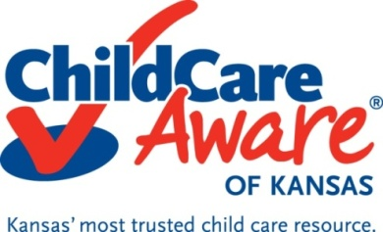

Professional Development Training

What is Professional Development Training?
Professional Development training is a continuum of learning designed to prepare individuals for work with and on behalf of young children and their families, as well as ongoing experiences to enhance this work. These opportunities lead to improvements in the knowledge, skills, practices, and dispositions of early education professionals.

Where is Professional Development Training Available?
Offered through local Child Care Resource & Referral Agencies
Child Care Resource & Referral agencies ensure child care providers have access to professional development, both geographically and financially.
Some training offered statewide includes:
- Basic Child Development
- Child Abuse & Neglect with Head Trauma
- Safe Sleep
- Social and Emotional Foundations for Early Learning
- Physical Activity in Young Children
- Nutrition
- Family Partnerships

Offered Online
The Child Care Aware Training Academy™ is online training designed to help you complete annual training requirements and obtain required training hours for those seeking a Child Development Associate (CDA) credential or CDA credential renewal. Register for online classes at www.ks.childcareware.org
Some training offered includes:
- Stages of Physical Growth and Development in Preschoolers
- Stages of Physical Growth and Development in Infants
- Stages of Physical Growth and Development in Toddlers
- Administration of Medication to Young Children
- Managing Infectious Diseases
- Shaken Baby Syndrome and Sudden Infant Death Syndrome
- Children's Temperaments
- Working with Children with Disabilities
- Child Abuse: Identification and Reporting
- Daily Schedule and Routines

Where do I find Professional Development Training information?
To find a professional development training in your area check out the statewide calendar or to register for an online course through the Child Care Aware Training Academy™ log on to Child Care Aware® of Kansas website at www.ks.childcareware.org.

