Accessing the Online Provider Profile Registry
to Upload Grant Documents

Licensed Child Care Programs may access the Online Provider Profile Registry by clicking on the link provided in the Kansas Child Care Relief Grant email or by clicking on the link from our website.
If you have already created a login email and password within WLS, you will be automatically logged into your Provider Profile Account.
If you have not created a login email and password within WLS, you will be directed to the login page and will select Create Account and complete the fields in the displayed text box.
If you have an account in WLS but do not know your password, you will enter the email address used to receive emails from Child Care Aware of Kansas in the Email Address field and select Request Password. An email will be sent to the email address provided and contains the instructions to reset your password.
If you are unsure of the email listed in your account, you may call the Child Care Aware of Kansas office and request assistance. We are able to provide you the email address in your Provider Profile Account but for security reasons will not be able to provide you with the password. Please enter the email provided by Child Care Aware of Kansas in the Email Address field and select Request Password. An email will be sent to the email address provided and contains the instructions to reset? your password.

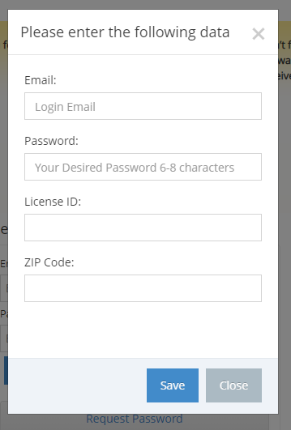
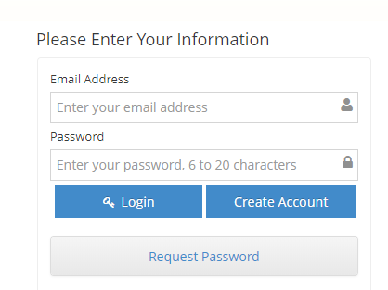

Once logged into the Provider Profile Registry, WLS will automatically display the grant application. Providers must first answer if their program is temporarily closed, either Yes or NO. The answer to this question will also determine the questions and grants that are specific to programs that are temporarily closed and programs that have remained open.

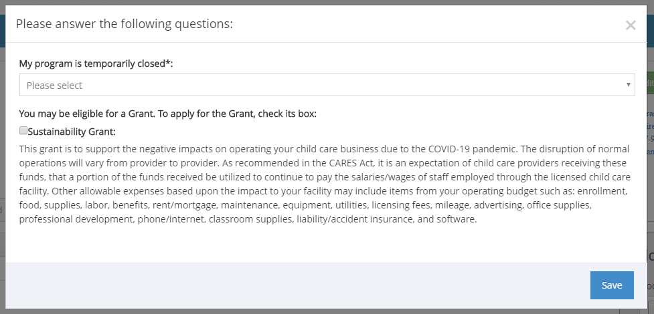

Child care programs that have temporarily closed will select Yes. Temporarily closed programs will have the ability to apply for the Sustainability Grant. To apply for the Sustainability Grant, please check the box next to the grant title, provide a short description or list of the expenses that will be paid by the grant and click Save. Please use the recommendations listed in the Sustainability Grant description to aid in selecting approved expenses.

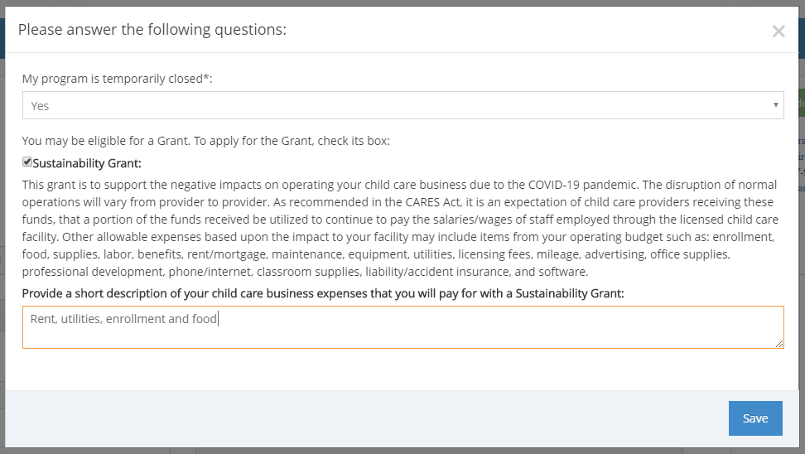

Child care programs that have remained open will select No. Open programs will have the ability to apply for the Sustainability Grant and the Supply Grant. To apply for the Sustainability Grant and/or Supply Grant, please check all appropriate boxes next to the grant title, provide a short description or list of the expenses that will be paid by the grant and click Save. Please use the recommendations listed in the Sustainability Grant description to aid in selecting approved expenses. You will be prompted to answer two additional questions shown below. Please enter Zero if none are available.

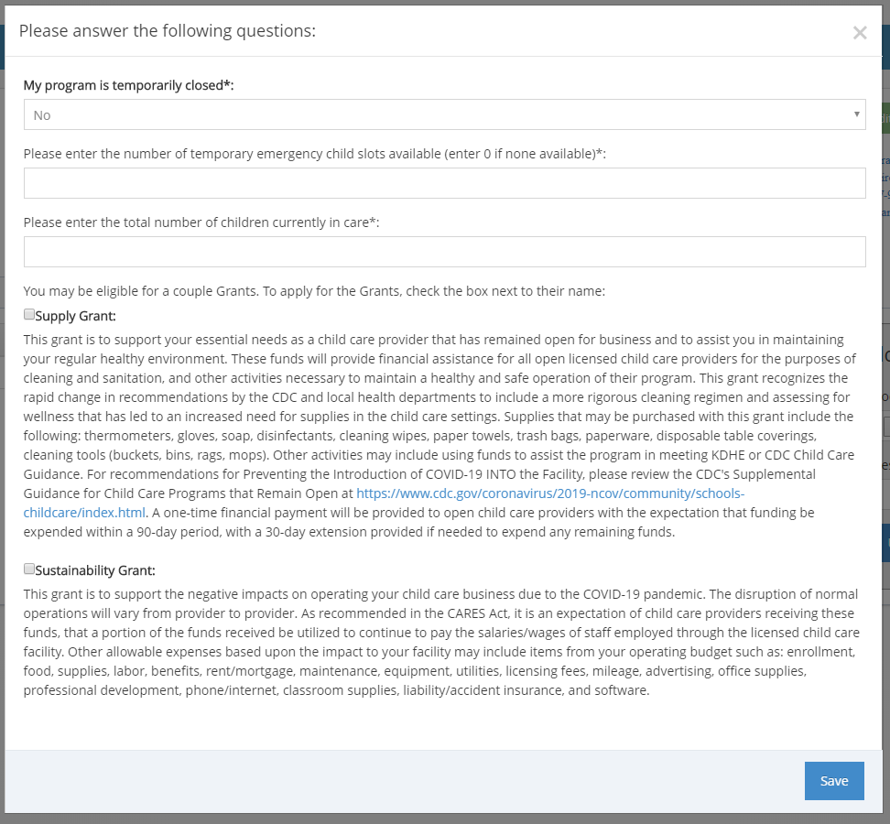

After you have clicked Save, a text box will be displayed with links to the additional required documents including the Direct Deposit Form, the W-9 and the Kansas Grant Signature Page.

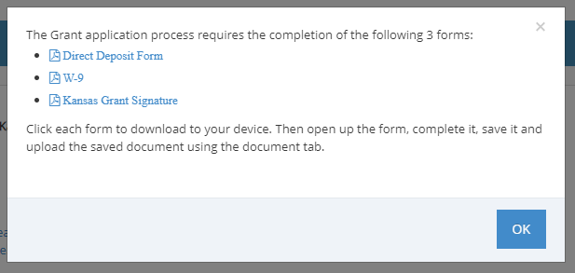

When you have completed all the documents and are ready to upload them, click on the Documents tab in your provider profile account. Click on Choose File and select the doucment you would like to upload. Enter the name of the document in the description and click Upload.
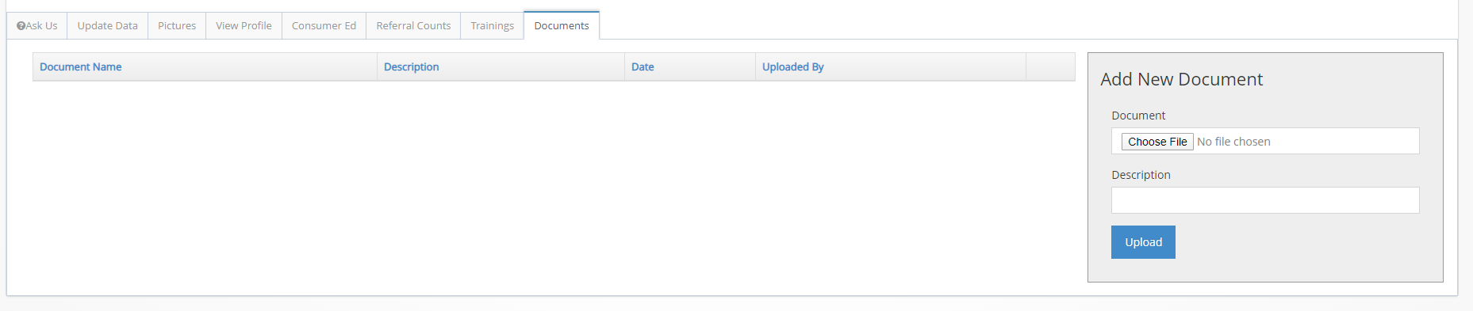
If you closed the text box before selecting all the documents, you can also access them in the upper right corner of your provider profile account. In addition to the required documents, the Grant FAQ is also available to help answer questions about the grants. If you need to change the status of your program or access the grant application, click on the gren Edit COVID-19 Status box.

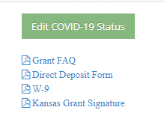

Once you have completed the grant application, please review and update your provider profile by selecting the Update Data tab.
The Contact Information section will be expanded when you log into your provider profile account. Click the + icon next to each section title to expand that section. Please complete all sections before clicking save.

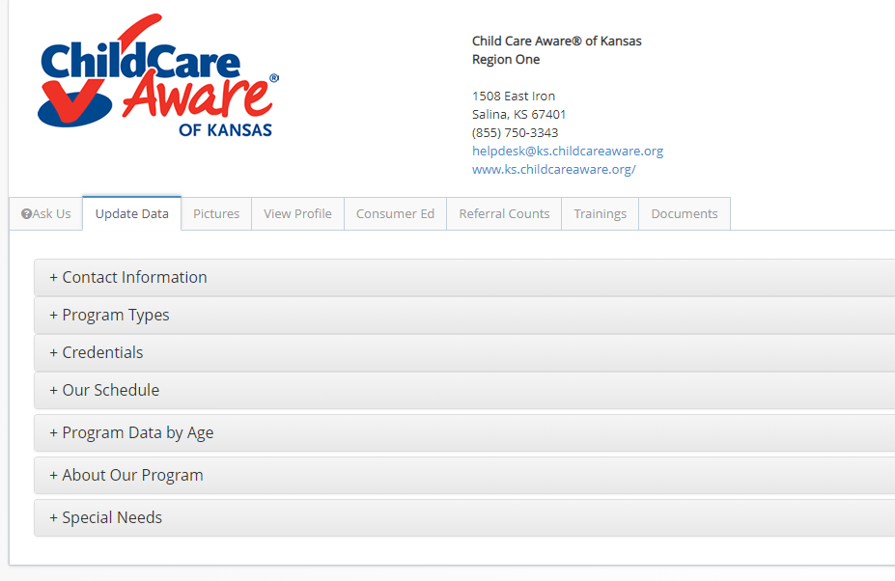
In the About Our Program section, please answer the question below once you have reviewed all your information and your profile is up to date.

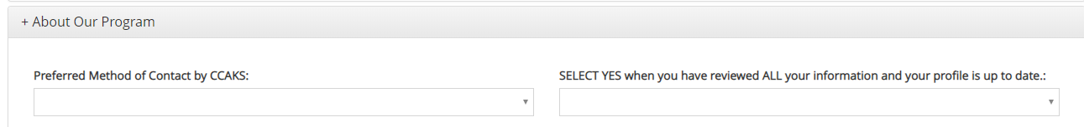
After reviewing and updating your profile, please click Save to finalize the updates. Please note the updates will be visible in your provider profile after approved by Child Care Aware of Kansas staff.

